There are mainly two components of RAG which we evaluate 1. Retrieval component and 2. Answer Generation Component
Let’s discuss first the retrieval matrix: It focuses on how well the system retrieves relevant information from its knowledge base. We use four metrices to do that: Precision, Recall, Hit Rate, Mean Reciprocal Rank (MRR) and Normalized Discounted Cumulative Gain (NDCG).
- Precision – It measures the proportion of relevant documents among the retrieved documents. Its particularly useful when you want to ensure that the information your system retrieves is highly relevant.
- Recall – Recall measures the proportion of relevant documents that were successfully retrieved. Its crucial in scenarios where missing important information could be costly.
- Hit Rate – It measures the proportion of queries for which at least one relevant document is retrieved within the top few results and you decide of how many results.
- MRR – One of the most used. It evaluates how high the first relevant document appears in the search result. Useful for systems where users prioritize top results. i.e. Web Search.
- NDCG – Takes relevance and the ranking of retrieved documents into account. Useful where the orders of results matter. i.e. Recommendation System.
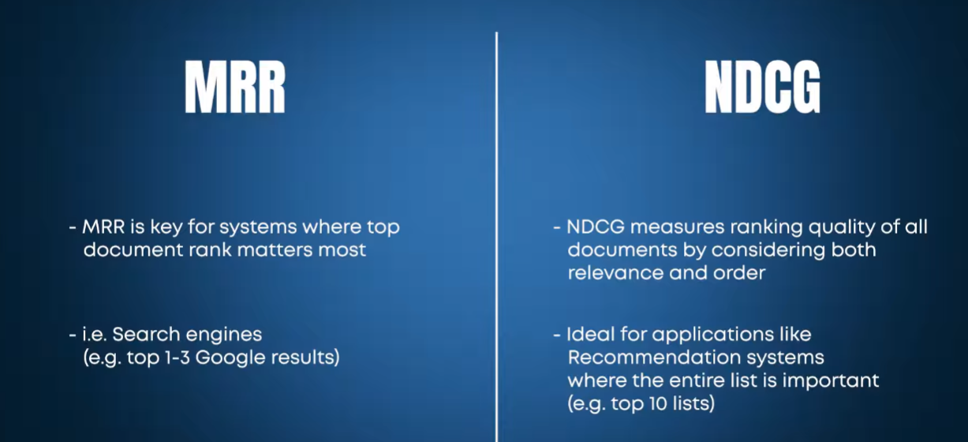
Now let’s discuss the Generation matrix. We have three main metrics to do that. 1. Faithfulness 2. Answer Relevancy 3. Answer Correctness
- Faithfulness - 
- Answer Relevancy - 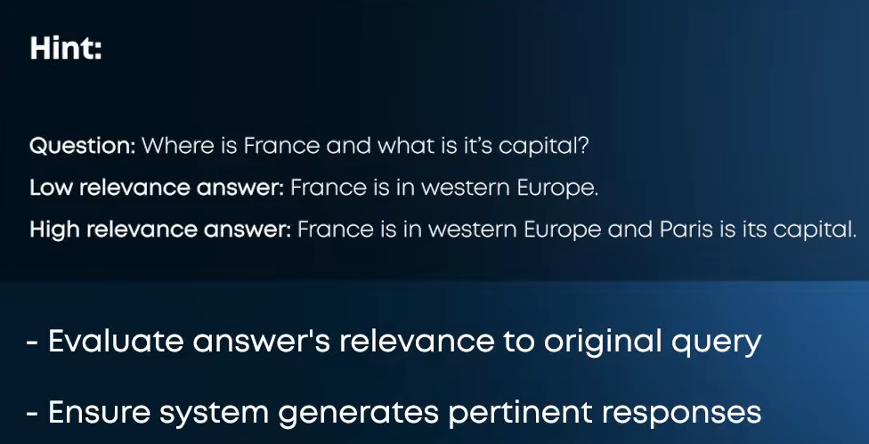
3. Answer Correctness - 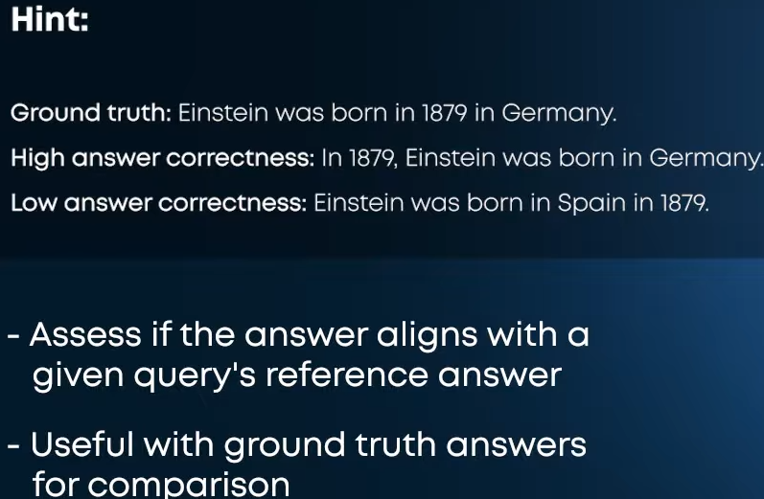

We need a dataset to evaluate them. Use CoT to see how llm Is thinking.

Effective way to understand User Needs:
- Logging user queries
- Analysing user queries
- 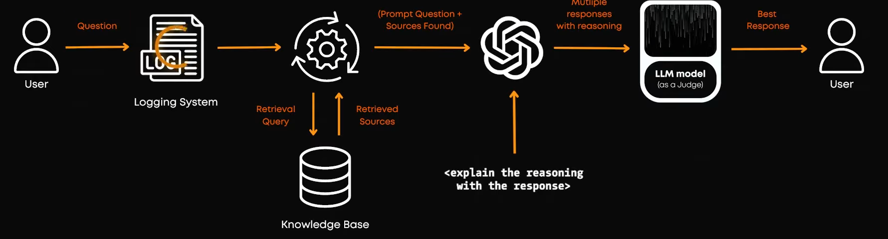

You can use LangSmith, RAGAS tools to evaluate by automation.

Last human evaluation is also very important. It can be done through example- A/B testing.
what is a/b testingA/B testing, also known as split testing, is a scientific experimentation method where two versions of a webpage, app, or marketing asset are compared to determine which one performs better. It works by randomly showing Version A (the original control) and Version B (the variant with one specific change) to different segments of live users. Software tracking tools then run a statistical analysis to see which version drives more conversions, clicks, or sales.

